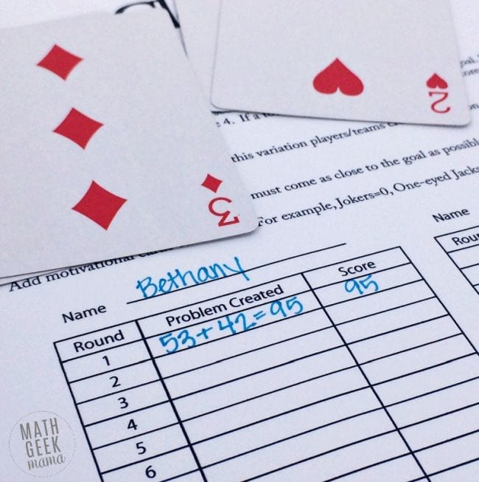

To play Close Call, each player deals themselves four cards then determines how to arrange them so they make two two-digit numbers that add up close to 100 without going over. For a subtraction version, work to get as close to zero as possible.

How to Play Close Call:
The object of this game is to accumulate the highest score by coming closer to the goal than your opponent.
Start with a complete deck of cards. Ace = 1, Joker = 0 and all tens and other face cards are removed. Shuffle the deck and deal each player 6 cards.
Players then select 4 of the cards to create two 2-digit numbers. The object is to create two numbers that when added together come as close to 100 as possible, without going over.
For example, in this hand I selected the cards 2,3,4, and 5.
I was then able to create the numbers 53 and 42, which when added together total 95.

Variations to the Game for Grade 6
Option A: Players then select 4 of the cards to create two 2-digit numbers. The object is to create two numbers that when added together come as close to 1000 as possible, without going over.
Option B: Players then select 6 of the cards to create two 3-digit numbers. The object is to create two numbers that when added together come as close to 1000 as possible, without going over.

Option C: (we have not covered integers yet so this would be a real challenge!)
Or for a greater challenge for older kids, practice with integer operations. Make black cards positive and red cards negative, and again, challenge kids to combine numbers to get as close to zero as possible.

How to Win Close Call:
The player with the total closest to 100 wins the round and 1 point. In the event of a tie, each player receives a point.
After playing 5 rounds, the player with the most points wins.
Alternatively, you could continue playing rounds until someone reaches 5 points.
To further aid with addition practice, you could also add the total from each round to calculate the total points. Then the player with the highest score wins.

